**Multiple Choice Questions: Circle** the correct option or options (if more than one is correct) for the following questions. Once marked, any cutting will lead to 0 mark for the MCQ. **[10 marks]**

**1. The given hexadecimal number (1E.53)16 is equivalent to:**a) (35.684)8  **b) (36.246)8** c) (34.340)8 d) (35.599)8

**2. The octal number (651.124)8 is equivalent to ______  
a) (1A9.2A)16** b) (1B0.10)16 c) (1A8.A3)16 d) (1B0.B0)16

**3. Binary subtraction of 101101 – 001011 = ?  
a) 100010** b) 010110 c) 110101 d) 101100

**4. The binary number 10001101010001101111 can be written in hexadecimal as**

(a) AD46716 b) 8C46F16  **c) 8D46F16** (d) AE46F16

**5. On subtracting (010110)2 from (1011001)2 using 2’s complement, we get ____________**a) 0111001 b) 1100101 c) 0110110 **d) 1000011**

**6, On addition of +38 and -20 using 2’s complement, we get ____________**a) 11110001 b) 100001110 **c) 010010** d) 110101011

**7. An overflow occurs in _________  
a) MSD position** b) LSD position c) Middle position d) Signed Bit *(MSD|LSD , D refers to digit)*

**8. The advantage of 2’s complement system is that _________  
a) Only one arithmetic operation is required** b) Two arithmetic operations are required

c) No arithmetic operations are required d) Different Arithmetic operations are required

**9. For arithmetic operations only _________**  
a) 1’s complement is used **b) 2’s complement** c) 10’s complement d) 9’s complement

**10. The excess-3 code for 597 is given by __________  
a) 100011001010**  b) 100010100111 c) 010110010111 d) 010110101101

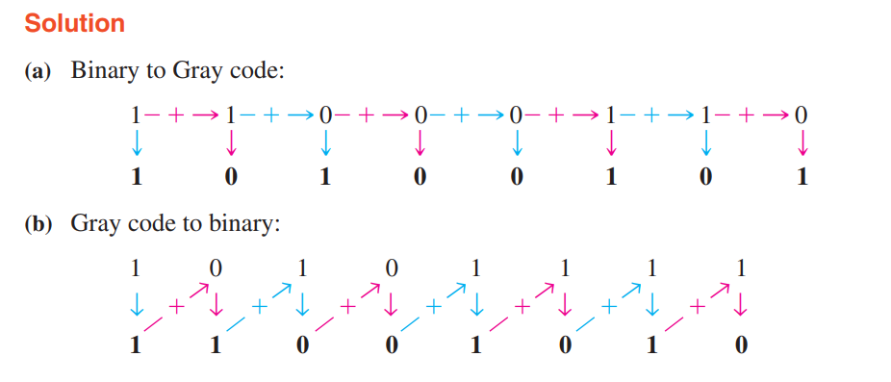

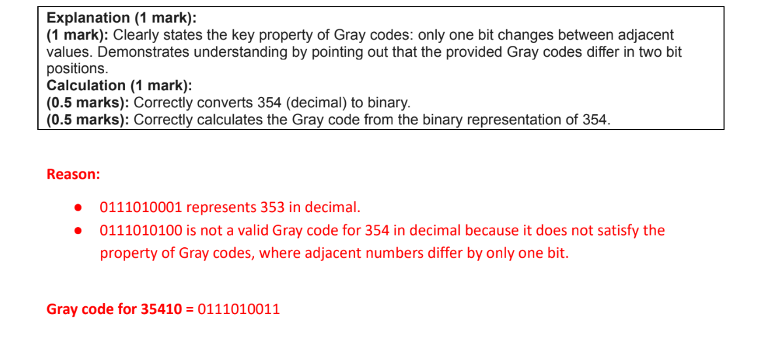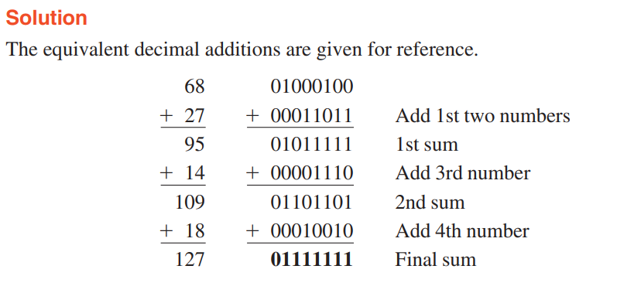

**Question 6:**

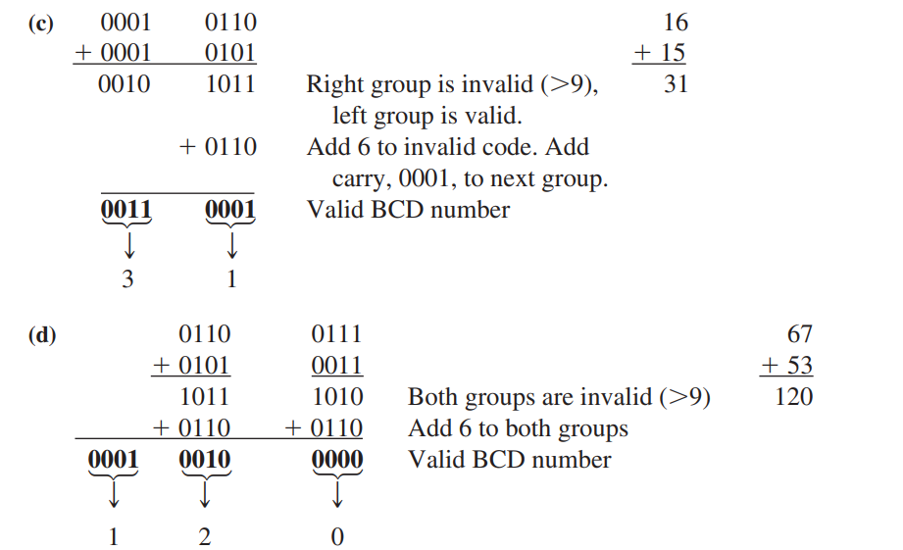

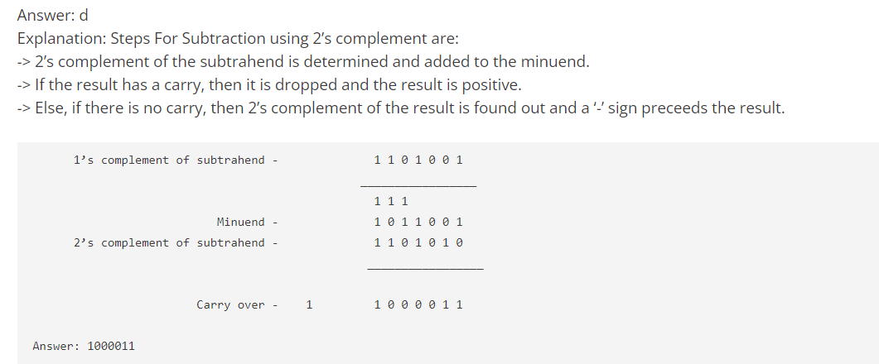

MCQ 8th : Explanation: The advantage of 2’s complement is that only one arithmetic operation is required for 2’s complement’s operation and that is only addition. Just by adding a 1 bit to 1’s complement, we get 2’s complement.